==================================================

Running Genetic Algorithm with HistGradientBoosting...

==================================================

==================================================

=== GENETIC ALGORITHM OPTIMIZATION ===

==================================================

[Initialization]

- Population size: 30

- Generations: 20

- Crossover rate: 80%

- Mutation rate: 20%

- Search space: 50 features

- Target: Minimize MSE using HistGradientBoosting

==================================================

=== OPTIMIZATION RESULTS ===

==================================================

▶ Best MSE achieved: 0.143515

▶ Time elapsed: 667.44 seconds

▶ Features selected: 21/50 (58.0% reduction)

▶ Selected features:

1. CreditScore

2. AnnualIncome

3. LoanDuration

4. Age

5. NumberOfOpenCreditLines

6. DebtToIncomeRatio

7. InterestRate

8. PaymentHistory

9. SavingsAccountBalance

10. RetirementAccountBalance

11. EmergencyFundBalance

12. TotalAssets

13. RentPayments

14. AutoLoanBalance

15. PersonalLoanBalance

16. HealthInsuranceStatus

17. LifeInsuranceStatus

18. CarInsuranceStatus

19. OtherInsurancePolicies

20. AnnualExpenses

21. MonthlyEntertainmentCosts

▶ Convergence progress:

- Initial MSE: 0.1436

- Final MSE: 0.1435

- Improvement: 0.0%

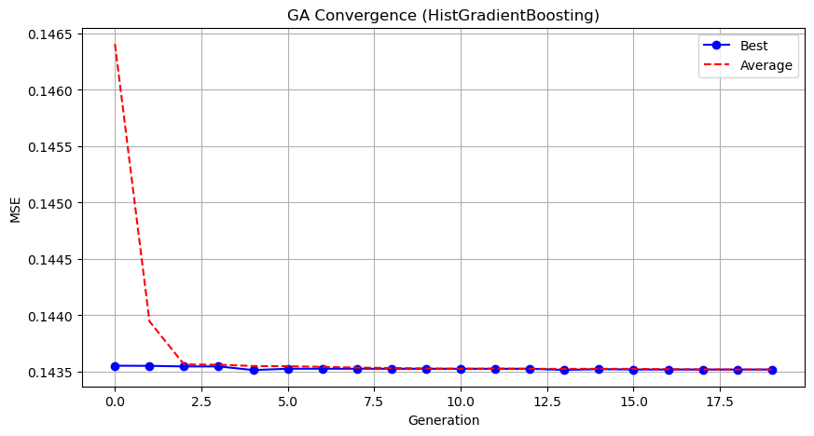

Genetic Algorithm completed successfully with MSE: 0.1435

==================================================

Running Particle Swarm Optimization with HistGradientBoosting...

==================================================

==================================================

=== PARTICLE SWARM OPTIMIZATION ===

==================================================

[Initialization]

- Swarm size: 30 particles

- Iterations: 20

- Cognitive weight: 0.5

- Social weight: 0.5

- Inertia weight: 0.5

- Search space: 50 features

==================================================

=== OPTIMIZATION RESULTS ===

==================================================

▶ Best MSE achieved: 0.143547

▶ Time elapsed: 84.15 seconds

▶ Features selected: 25/50 (50.0% reduction)

▶ Selected features (with weights):

1. CreditScore (weight: 1.000)

2. AnnualIncome (weight: 0.611)

3. LoanDuration (weight: 0.721)

4. NumberOfDependents (weight: 0.659)

5. EducationLevel (weight: 1.000)

6. HomeOwnershipStatus (weight: 0.816)

7. NumberOfOpenCreditLines (weight: 0.705)

8. PaymentHistory (weight: 1.000)

9. RetirementAccountBalance (weight: 1.000)

10. EmergencyFundBalance (weight: 0.898)

11. NetWorth (weight: 1.000)

12. LengthOfCreditHistory (weight: 0.912)

13. RentPayments (weight: 0.612)

14. AutoLoanBalance (weight: 0.674)

15. StudentLoanBalance (weight: 1.000)

16. UtilityBillsPaymentHistory (weight: 0.774)

17. HealthInsuranceStatus (weight: 1.000)

18. LifeInsuranceStatus (weight: 1.000)

19. OtherInsurancePolicies (weight: 0.531)

20. JobTenure (weight: 1.000)

21. MonthlySavings (weight: 0.866)

22. AnnualExpenses (weight: 0.854)

23. MonthlyTransportationCosts (weight: 0.675)

24. MonthlyFoodCosts (weight: 0.716)

25. MonthlyHealthcareCosts (weight: 0.725)

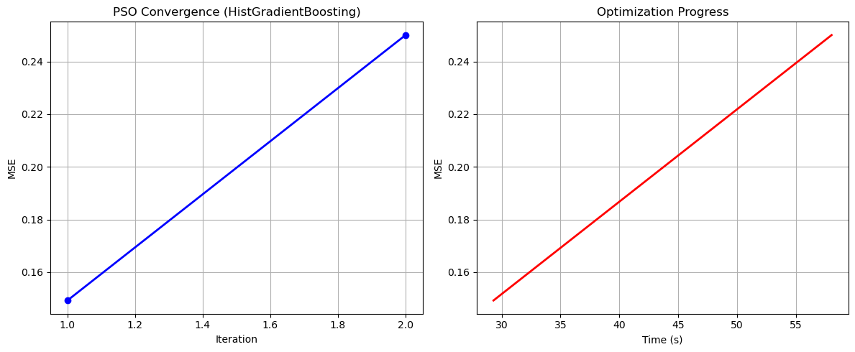

Particle Swarm Optimization completed successfully with MSE: 0.1435

==================================================

Running Whale Optimization with HistGradientBoosting...

==================================================

==================================================

=== WHALE OPTIMIZATION ALGORITHM ===

==================================================

[Initialization]

- Population: 30 whales

- Max iterations: 20

- Spiral coefficient (b): 1.0

- Search space: 50 features

- Target: Minimize MSE using HistGradientBoosting

[Optimization Progress]

Iter 20/20 | Best MSE: 0.143537

==================================================

=== OPTIMIZATION RESULTS ===

==================================================

▶ Best MSE achieved: 0.143537

▶ Time elapsed: 726.18 seconds

▶ Features selected: 30/50 (40.0% reduction)

▶ Selected features:

1. CreditScore

2. AnnualIncome

3. LoanAmount

4. LoanDuration

5. Age

6. EmploymentStatus

7. MaritalStatus

8. EducationLevel

9. MonthlyDebtPayments

10. CreditCardUtilizationRate

11. NumberOfOpenCreditLines

12. NumberOfCreditInquiries

13. LoanPurpose

14. PreviousLoanDefaults

15. RetirementAccountBalance

16. TotalAssets

17. NetWorth

18. MortgageBalance

19. RentPayments

20. AutoLoanBalance

21. StudentLoanBalance

22. LifeInsuranceStatus

23. CarInsuranceStatus

24. HomeInsuranceStatus

25. EmployerType

26. JobTenure

27. MonthlySavings

28. AnnualExpenses

29. MonthlyHousingCosts

30. MonthlyEntertainmentCosts

▶ Convergence progress:

- Initial MSE: 0.1493

- Final MSE: 0.1436

- Improvement: 3.8%

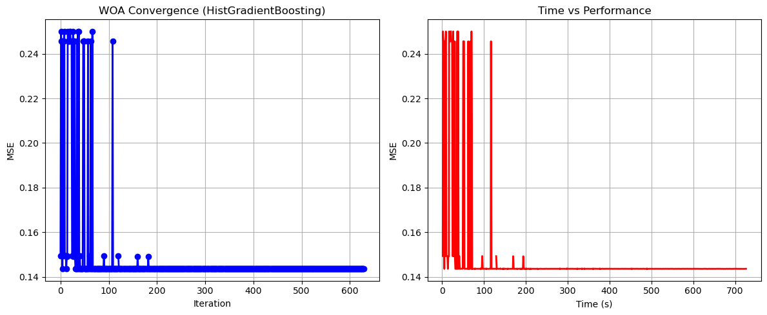

Whale Optimization completed successfully with MSE: 0.1435

==================================================

Running Squid Game Optimizer with HistGradientBoosting...

==================================================

==================================================

=== SQUID GAME OPTIMIZER (SGO) ===

==================================================

[Initialization]

- Players: 30 (15 offensive, 15 defensive)

- Max games: 20

- Search space: 50 features

- Target: Minimize MSE using HistGradientBoosting

==================================================

=== OPTIMIZATION RESULTS ===

==================================================

▶ Best MSE achieved: 0.143520

▶ Time elapsed: 698.65 seconds

▶ Features selected: 22/50 (56.0% reduction)

▶ Selected features:

1. CreditScore

2. AnnualIncome

3. Age

4. NumberOfDependents

5. HomeOwnershipStatus

6. NumberOfCreditInquiries

7. DebtToIncomeRatio

8. BankruptcyHistory

9. InterestRate

10. SavingsAccountBalance

11. RetirementAccountBalance

12. AutoLoanBalance

13. PersonalLoanBalance

14. StudentLoanBalance

15. UtilityBillsPaymentHistory

16. HomeInsuranceStatus

17. EmployerType

18. JobTenure

19. MonthlySavings

20. AnnualExpenses

21. MonthlyFoodCosts

22. MonthlyEntertainmentCosts

▶ Convergence progress:

- Initial MSE: 0.1436

- Final MSE: 0.1435

- Improvement: 0.0%

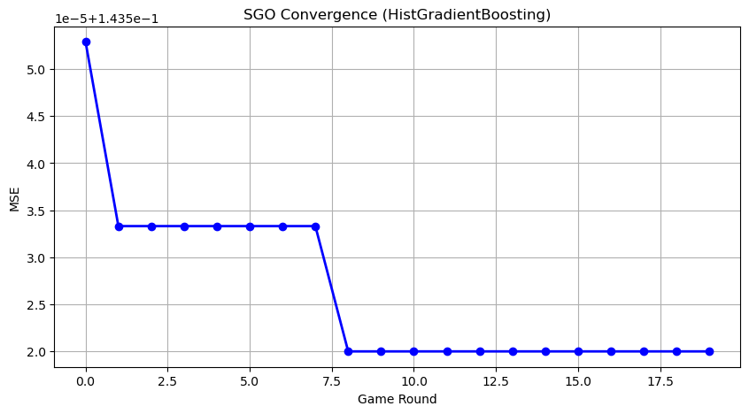

Squid Game Optimizer completed successfully with MSE: 0.1435

==================================================

Running PSH-Hyptrite with HistGradientBoosting...

==================================================

==================================================

=== PSH-HYPTRITE OPTIMIZATION ===

==================================================

[Initialization]

- Search points: 30

- Max iterations: 20

- Initial radius: 0.5 (adaptive)

- Hypersphere samples: 3 per point

- Search space: 50 features

- Target: Minimize MSE using HistGradientBoosting

[Optimization Progress]

Iter 20/20 | Best MSE: 0.143530 | Radius: 0.0250

==================================================

=== OPTIMIZATION RESULTS ===

==================================================

▶ Best MSE achieved: 0.143530

▶ Time elapsed: 2022.62 seconds

▶ Features selected: 23/50 (54.0% reduction)

▶ Selected features (with weights):

1. CreditScore (weight: 0.574)

2. AnnualIncome (weight: 0.741)

3. LoanDuration (weight: 0.962)

4. Age (weight: 0.783)

5. EmploymentStatus (weight: 0.537)

6. MaritalStatus (weight: 0.961)

7. EducationLevel (weight: 1.000)

8. HomeOwnershipStatus (weight: 0.975)

9. NumberOfOpenCreditLines (weight: 0.946)

10. PreviousLoanDefaults (weight: 0.985)

11. CheckingAccountBalance (weight: 0.541)

12. RetirementAccountBalance (weight: 0.727)

13. LengthOfCreditHistory (weight: 0.912)

14. AutoLoanBalance (weight: 0.571)

15. PersonalLoanBalance (weight: 0.627)

16. StudentLoanBalance (weight: 0.573)

17. HealthInsuranceStatus (weight: 0.522)

18. LifeInsuranceStatus (weight: 0.695)

19. CarInsuranceStatus (weight: 0.660)

20. HomeInsuranceStatus (weight: 0.976)

21. MonthlySavings (weight: 0.526)

22. AnnualBonuses (weight: 0.896)

23. MonthlyHealthcareCosts (weight: 0.625)

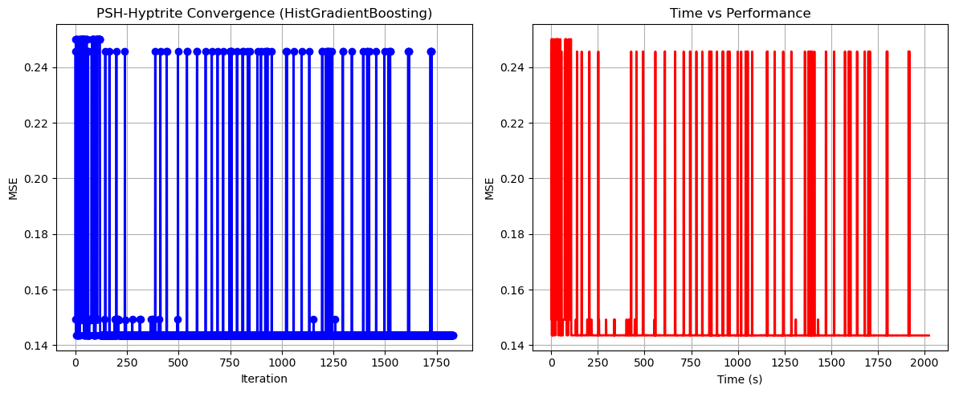

PSH-Hyptrite completed successfully with MSE: 0.1435

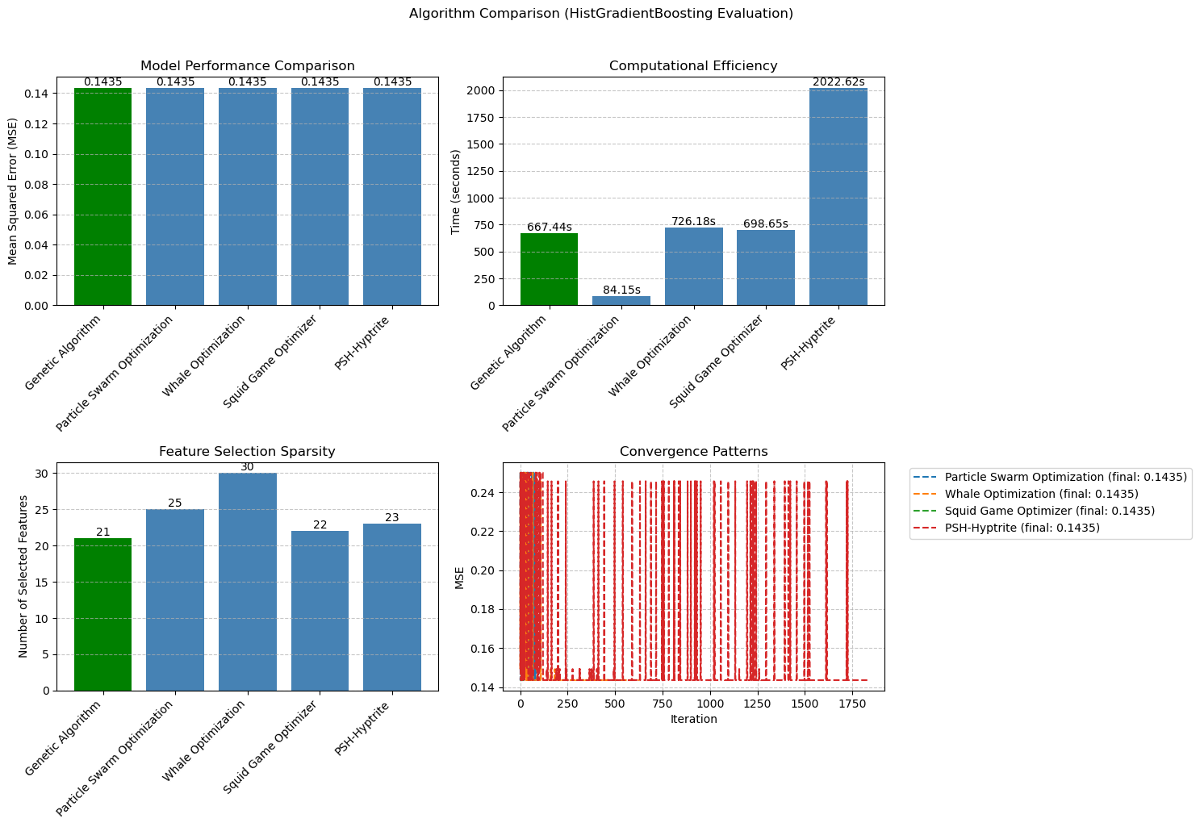

============================================================

=== FINAL FEATURE SELECTION RESULTS USING HistGradientBoosting ===

============================================================

🏆 BEST ALGORITHM: GENETIC ALGORITHM

• MSE: 0.143515

• Time: 667.44 seconds

• Features: 21/50 (58.0% reduction)

📊 COMPARISON TABLE:

Algorithm MSE Time (s) Features

---------------------------------------------------------------------------

Genetic Algorithm 0.143515 667.44 21

Squid Game Optimizer 0.143520 698.65 22

PSH-Hyptrite 0.143530 2022.62 23

Whale Optimization 0.143537 726.18 30

Particle Swarm Optimization 0.143547 84.15 25

🔍 SELECTED FEATURES:

1. CreditScore

2. AnnualIncome

3. LoanDuration

4. Age

5. NumberOfOpenCreditLines

6. DebtToIncomeRatio

7. InterestRate

8. PaymentHistory

9. SavingsAccountBalance

10. RetirementAccountBalance

11. EmergencyFundBalance

12. TotalAssets

13. RentPayments

14. AutoLoanBalance

15. PersonalLoanBalance

16. HealthInsuranceStatus

17. LifeInsuranceStatus

18. CarInsuranceStatus

19. OtherInsurancePolicies

20. AnnualExpenses

21. MonthlyEntertainmentCosts

💡 Tip: Consider feature importance from HistGradientBoosting for further analysis